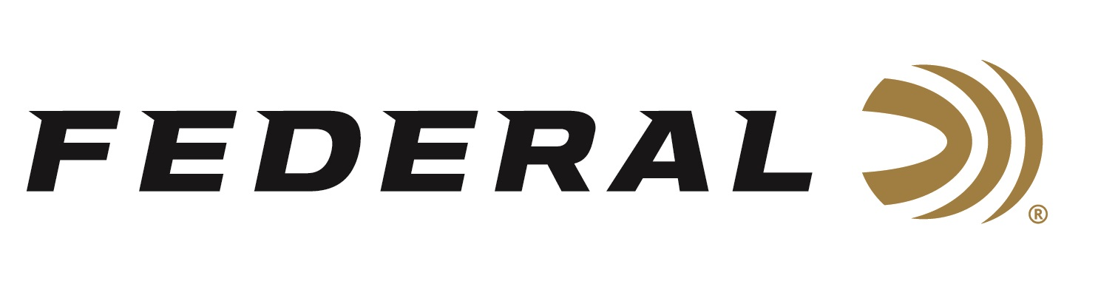

FOR IMMEDIATE RELEASE

Getting Fit for the Hunt on “It’s Federal Season” Podcast

ANOKA, Minnesota – November 5, 2020 – Getting the most out of every hunt or shooting competition by improving your fitness is the focus of the episode of “It’s Federal Season.” Former Navy Seal and founder of the CrossFit Games Dave Castro weighs in on why fitness not only improves your health but can improve your hunting and shooting experience.

Episode No. 15 - Getting Fit for the Hunt
https://www.federalpremium.com/podcast.html

“Dave has a great story on becoming a Navy Seal and how he got involved in the CrossFit craze,” says Jason Nash, Federal Ammunition’s Vice President of Marketing. “More important, he has great advice on how improved fitness can enhance your hunting and shooting skills,” stated Nash. Castro addresses getting started on CrossFit, the benefits of the program, and his journey on becoming a proficient shooter.

In the Tech Talk segment, Product Director Mike Holm weighs in on the proper mechanics of shooting and how and what practice before for your next hunt. Find out what promotions are currently running and take advantage of some great offers from Federal Ammunition.

Federal Ammunition can be found at dealers nationwide or purchased online direct from Federal. For more information on all products from Federal or to shop online, visit www.federalpremium.com.

Press Release Contact: JJ Reich
Senior Manager – Press Relations
E-mail: VistaPressroom@VistaOutdoor.com

About Federal Ammunition
Federal, headquartered in Anoka, MN, is a brand of Vista Outdoor Inc., an outdoor sports and recreation company. From humble beginnings nestled among the lakes and woods of Minnesota, Federal Ammunition has evolved into one of the world's largest producers of sporting ammunition. Beginning in 1922, founding president, Charles L. Horn, paved the way for our success. Today, Federal carries on Horn's vision for quality products and service with the next generation of outdoorsmen and women. We maintain our position as experts in the science of ammunition production. Every day we manufacture products to enhance our customers' shooting experience while partnering with the conservation organizations that protect and support our outdoor heritage. We offer thousands of options in our Federal Premium and Federal® lines-it's what makes us the most complete ammunition company in the business and provides our customers with a choice no matter their pursuit.

